DRUGS.COM SCRAPER TASK DOCUMENTATION

The task is to scrape each drug present on drugs.com for the following information: description , Drug Class , Side effects, Interactions, How to use.

Store the data in .csv format make the scraper such that in case of error the progress is not lost e.g. use csvwriter such that each drugs information gets written in the excel sheet as it is scraped.

Try to make it as efficient as possible. Check for exceptions and Do not scrape incomplete information

1. Go to A-Z Drug Index

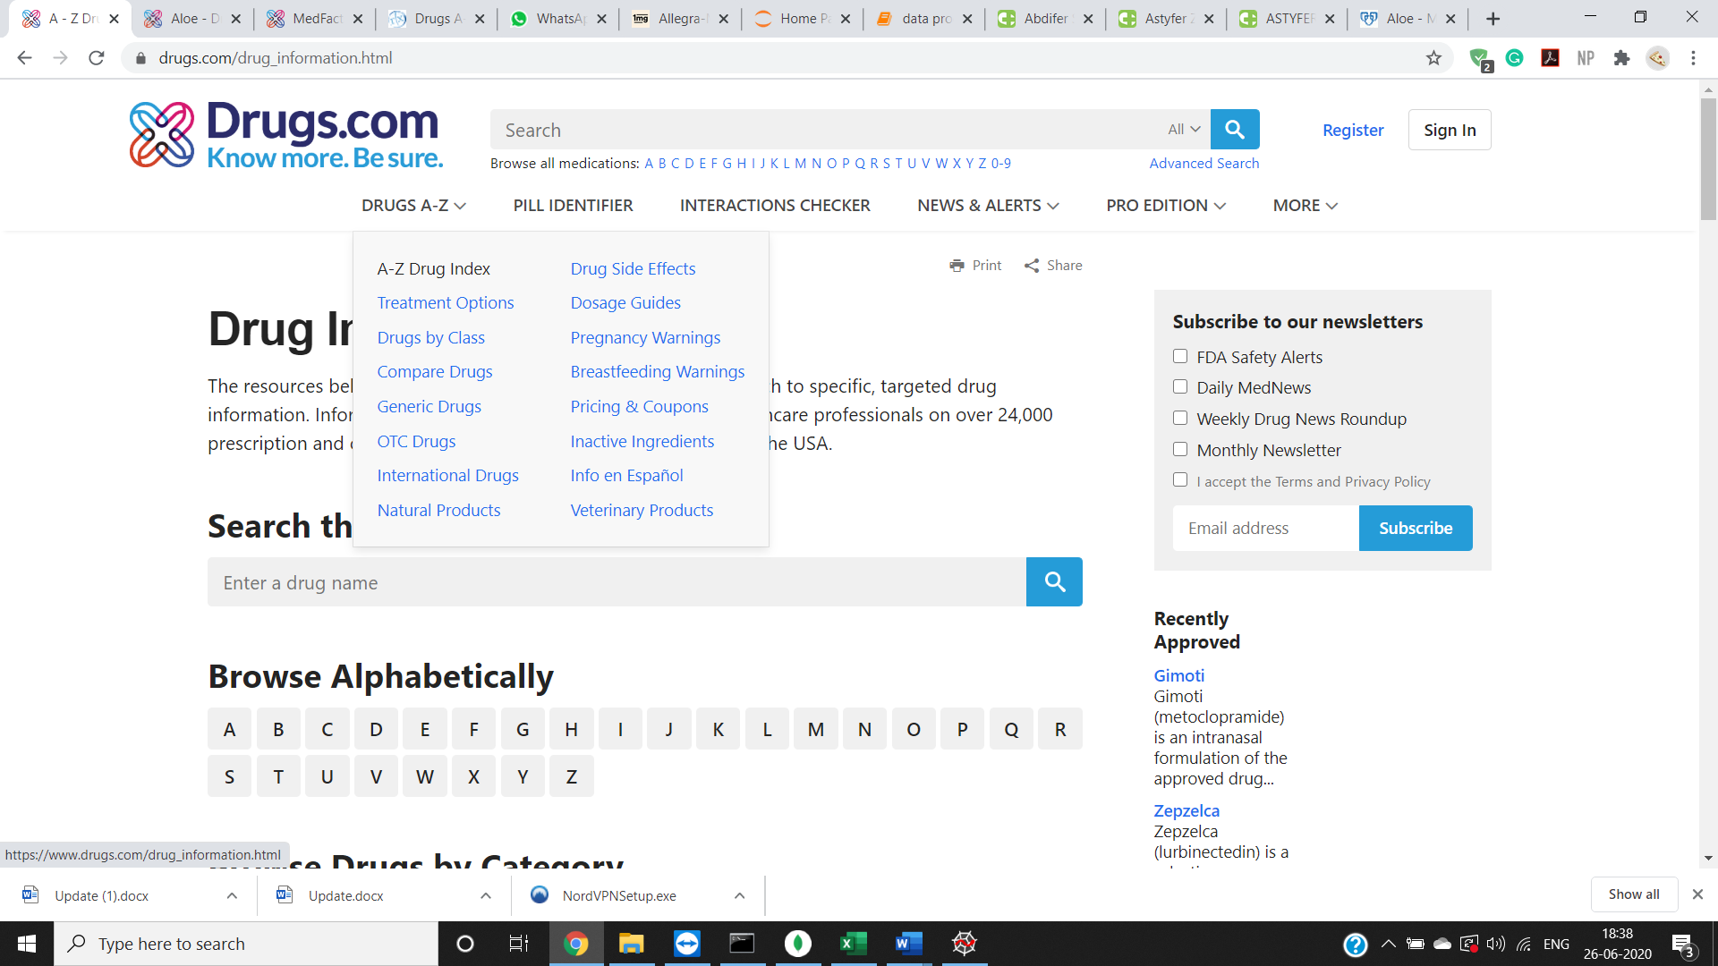

1. Browse Alphabetically and scrape for each alphabet

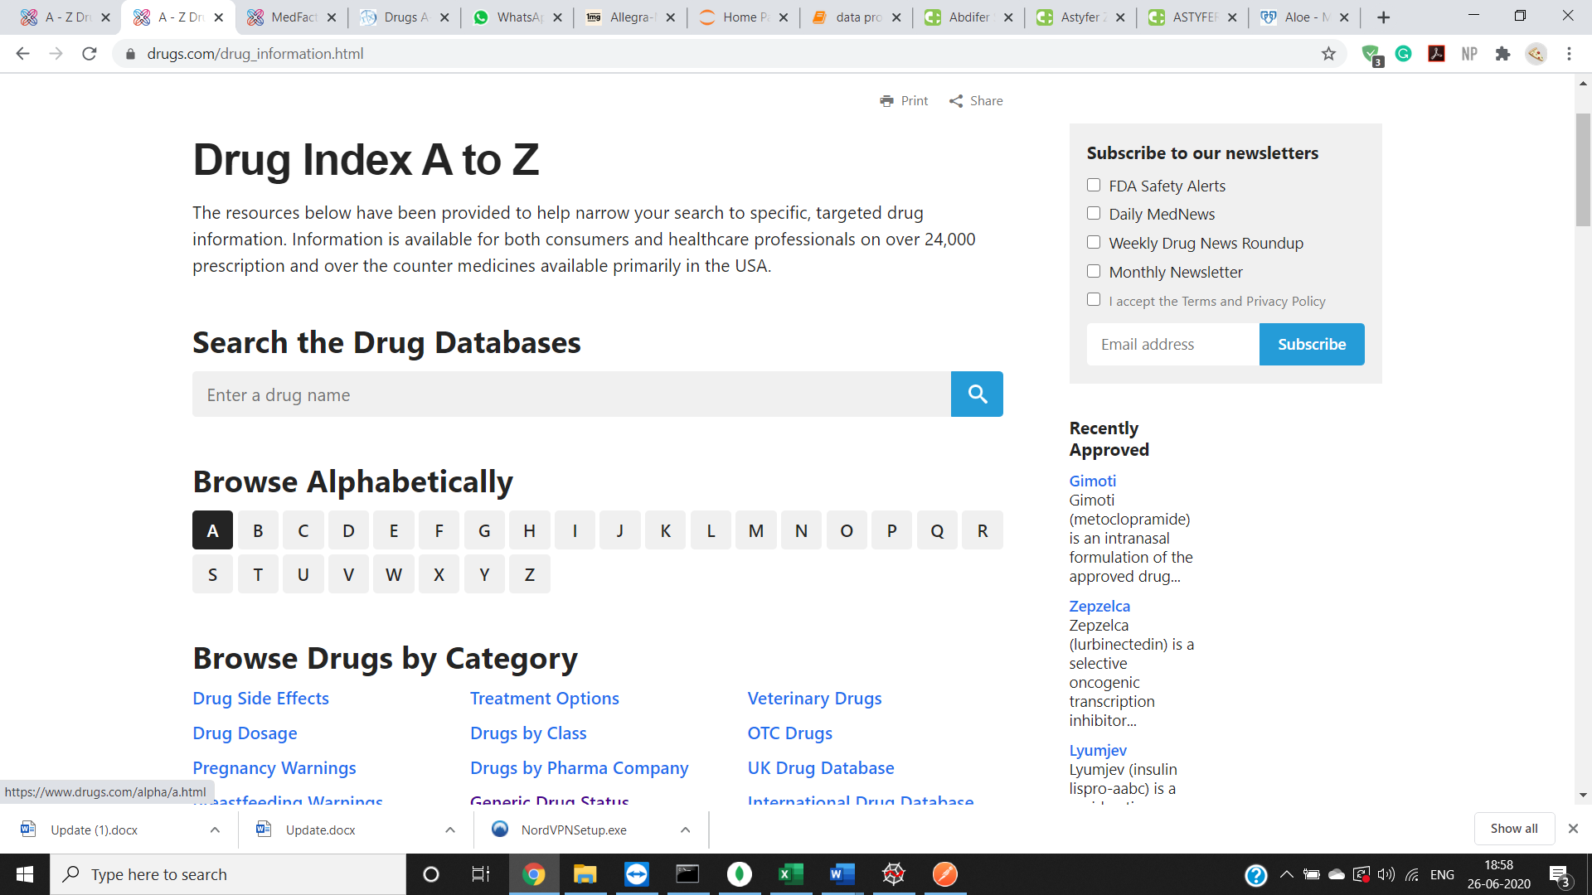

1. Scrape all the drugs present in each alphabet

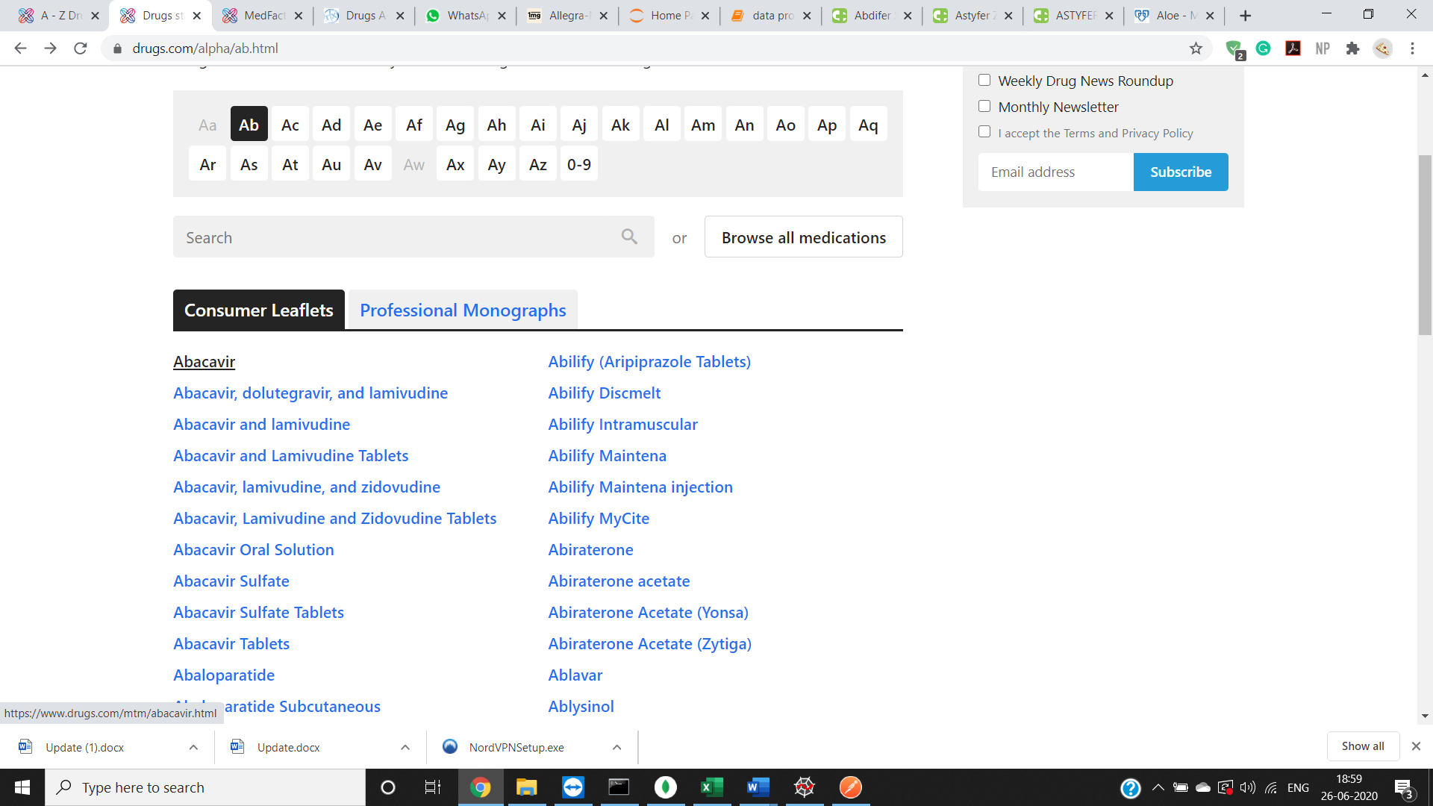

1. For Description : Scrape the “what is” section

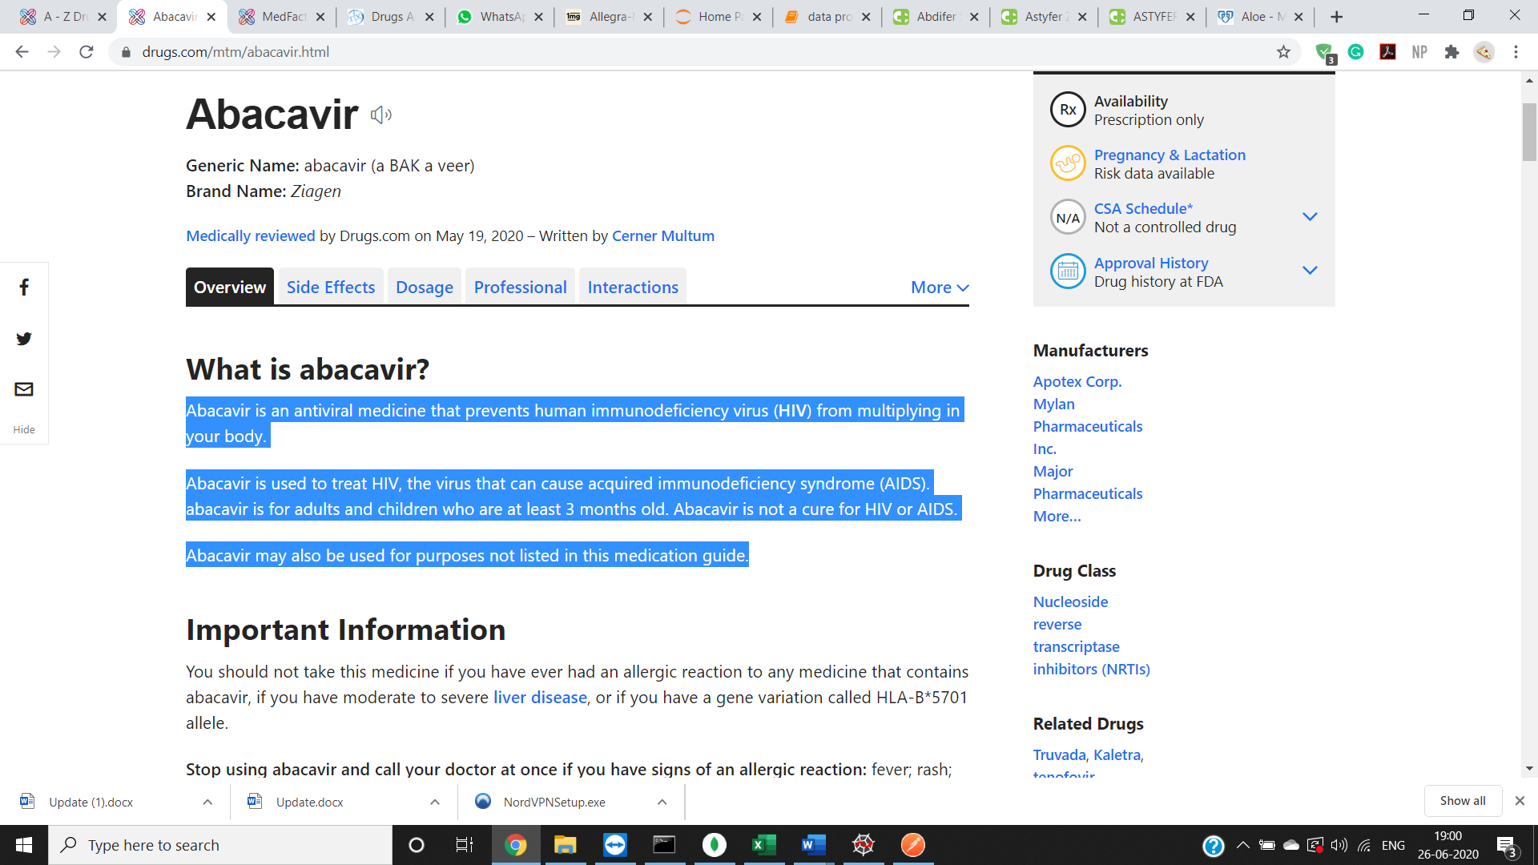

1. For Drug class: Scrape the drug class section as highlighted

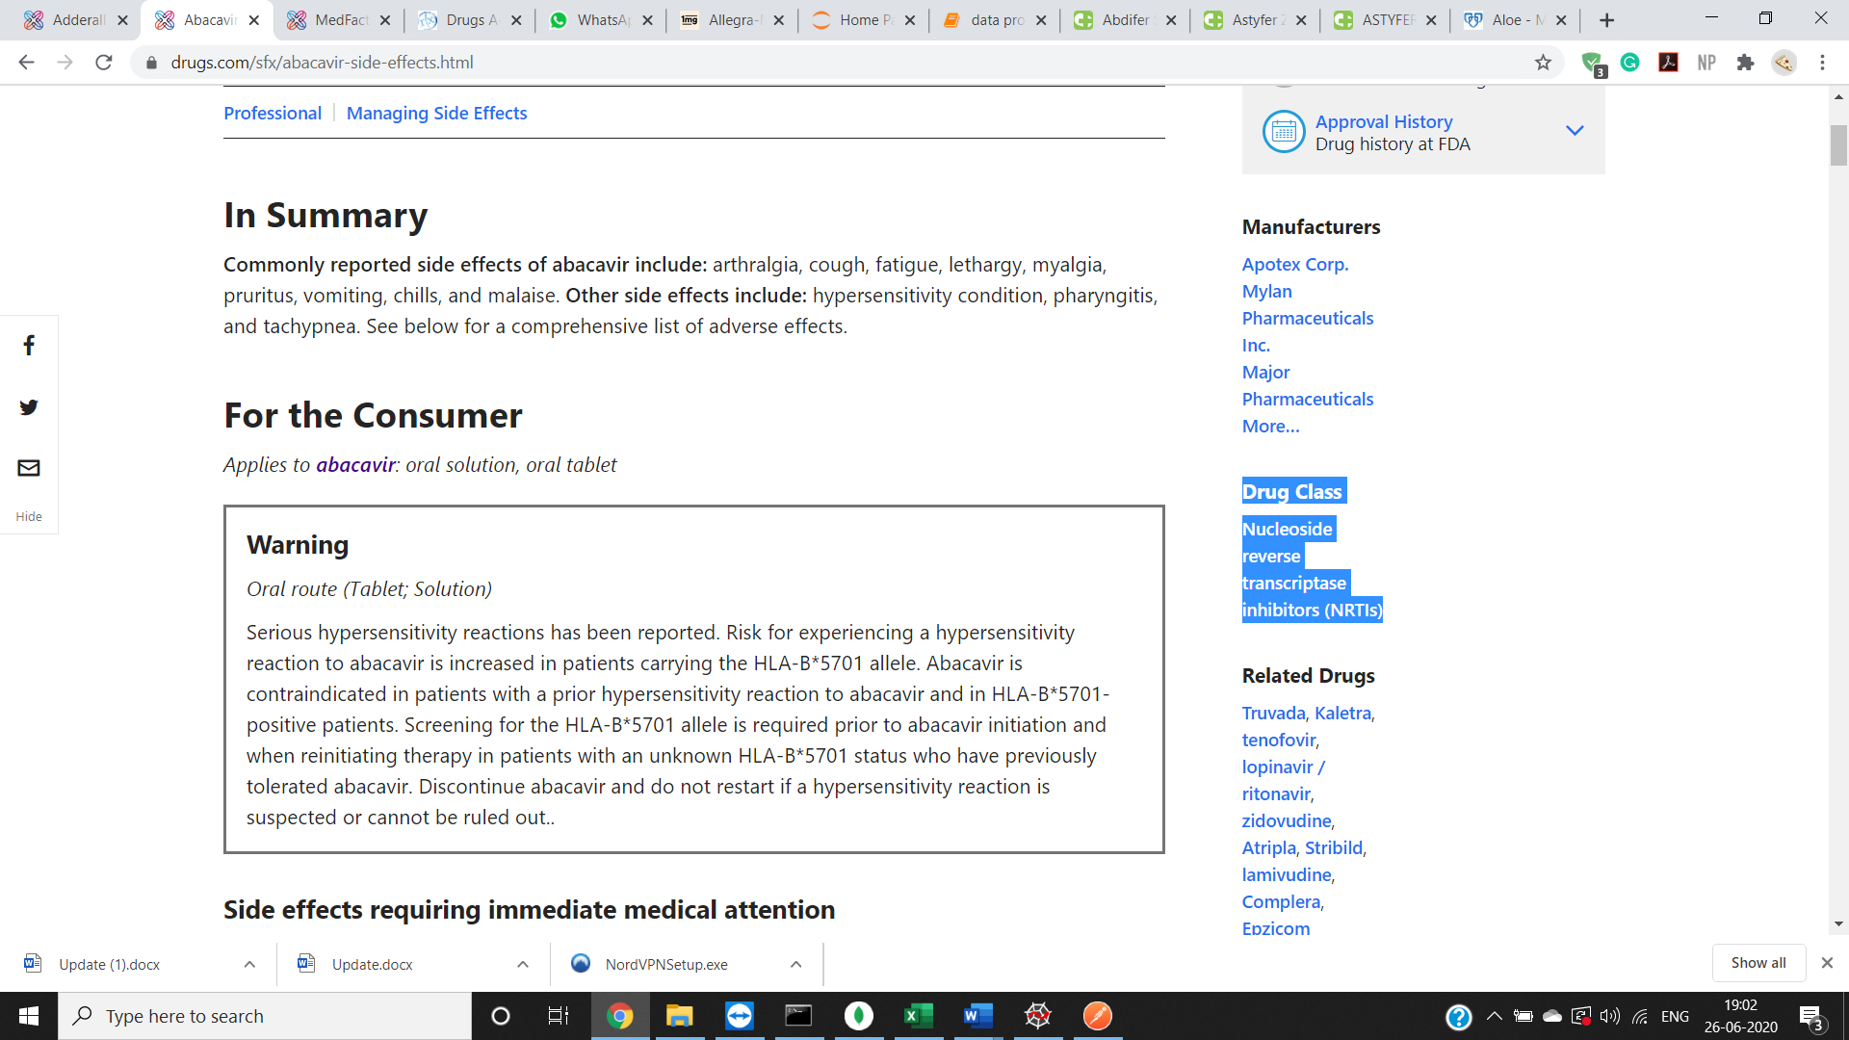

1. For interactions: Scrape the “what other drugs will affect” section

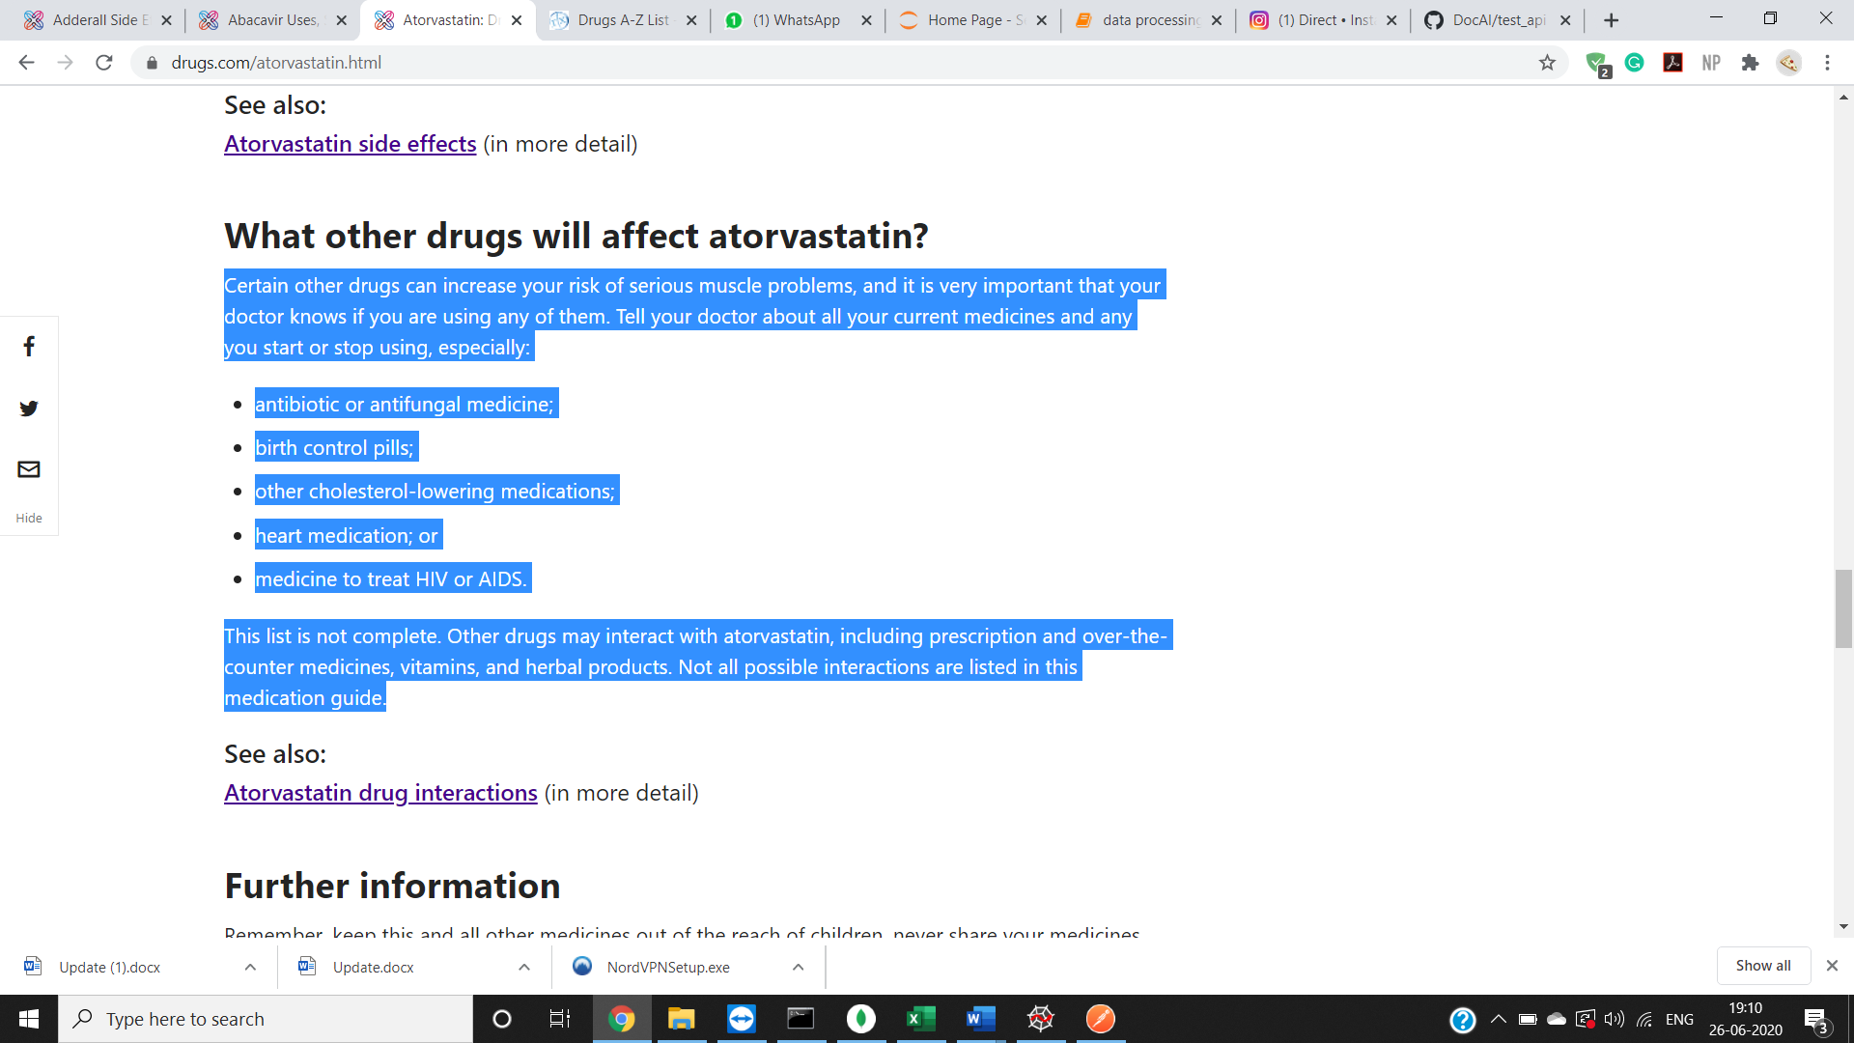

1. For Side Effects: Scrape the Side effects section

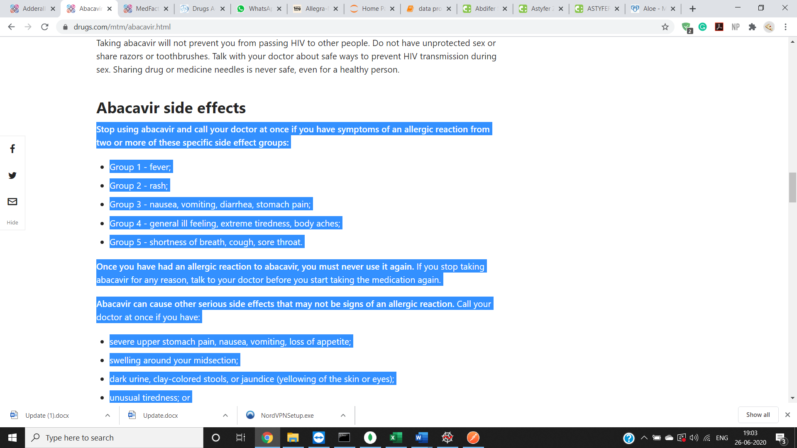

1. For How to use: Scrape the how should I take section as highlighted

